SHRADHA DIDI RESUME

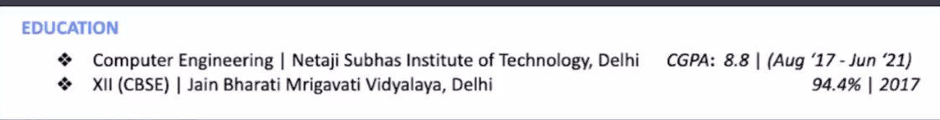
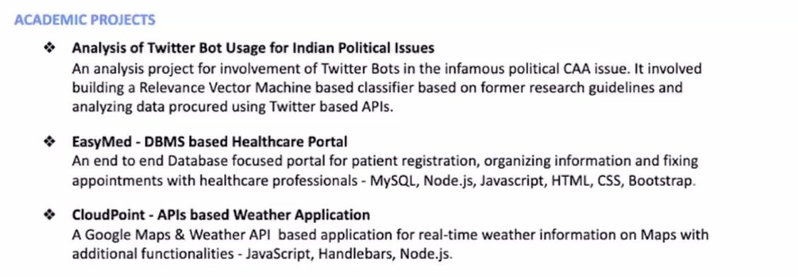
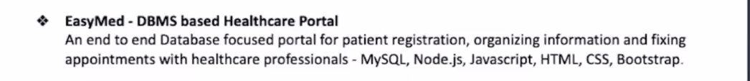
Experience:
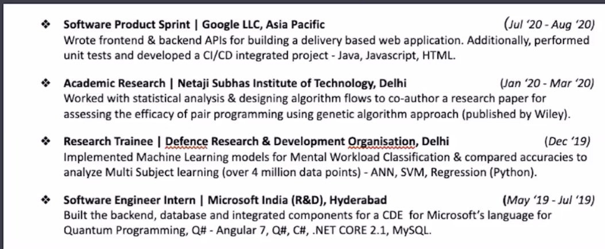

TECHNICAL SKILLS
Programming: Java(Data Structures and Algorithms) , Python , C ,HTML, CSS , SQL
Tools/Frameworks: React.js , Git , MySql Workbench,Node.js ,Express.js, DBMS , MongoDB , Bootstrap
Soft Skills: TeamWork , Critical Thinker , Active Listener , Adaptability,
EDUCATION
IT | G.NARAYANAMMA INSTITUTE OF TECHNOLOGY AND SCIENCE | GPA : 8.88
(YEAR OF GRADUATION : 2026)
PROJECTS
VisionSwap -Google Solution Challenge
–Led the development of an all-in-one destination portal connecting users with needed skills and facilitating seamless connections among users with complementary abilities.
– Implemented robust user authentication protocols on the backend to ensure secure and private user interactions.
–Engineered the platform to ensure constant availability, creating a dynamic environment where users can easily find and connect with others possessing the desired skills.
(MongoDb, Node.js, JS , HTML ,CSS, Bootstrap)
Link : https://visionswap.onrender.com/homePage
WanderLust – Home renta

